**TECHNICAL REPORT ON STUDENTS INDUSTRIAL WORK EXPERIENCE SCHEME (SIWES)**

**AT**

**POLIS COMPUTERS,**

**MICHIKA, ADAMAWA STATE**

**FROM: 4TH JANUARY, 2023**

**TO:4TH MAY, 2023**

**BY**

**VANDI TIMOTHY**

**ST/CS/ND/21/039**

**SUBMITTED TO THE DEPARTMENT OF COMPUTER SCIENCE, SCHOOL OF SCIENCE AND TECHNOLOGY, IN PARTIAL FULFILLMENT OF THE REQUIREMENT FOR THE AWARD OF NATIONAL DIPLOMA (ND), COMPUTER SCIENCE, FEDERAL POLYTECHNIC, MUBI, ADAMAWA STATE.**

**JUNE, 2023**

**DEDICATION**

I dedicate this technical report to my lovely parents who gave me all the support and care throughout my SIWES program.

# ACKNOWLEDGMENTS

I thank God Almighty for making me to undergo students industrial work experience scheme (SIWES) successfully.

My gratitude goes to my parent for their prayers, financial and moral support during my attachment.

I also appreciate the kind gesture of my brothers and sisters and those who supports me in prayers and contribution during my industrial attachment.

I whole heartedly thank my Head of department Mallam Adamu Garba Mubi, SIWES coordinator and all lectures of Computer Science for their effort to ensure my success as their students.

I am greatly indebted to my co-SIWES students to mention, may God strengthen our relationship together and grant us academic excellence.

I sincerely thank you all for your contribution and support.

**ABSTRACT**

*The report summarises the result of work done during my SIWES experience, the technical report consists of four chapters, which comprises of introduction, history and criteria’s of SIWES in chapter one followed by their aims and objectives, historical background, organizational structure of the organization in chapter two, while chapter three consist of the work actually carried out during the SIWES programme and lastly chapter four consist of the summary, conclusions and recommendation.*

**TABLE OF CONTENTS**

TITLE PAGE - - - - - - - - - i

DEDICATION - - - - - - - - ii

ACKNOLEDGEMENTS - - - - - - - iii

ABSTRACT - - - - - - - - - iv

**CHAPTER ONE**

1.0INTRODUCTION - - - - - - - - 1

1.1 THE NEED FOR SIWES - - - - - - - 1

1.2 DEFINITION OF SIWES - - - - - - - 1

1.3 AIMS AND OBEJECTIVE OF SIWES - - - - - 2

1.4 BRIEF HISTORY OF SIWES - - - - - - 2

1.5 THE SIGNIFICANT OF SIWES TO STUDENT - - - 2

**CHAPTER TWO**

2.1 BRIEF HISTORY OF THE ORGANIZATION - - - - 4

2.2 ORGANIZATIONAL CHART - - - - - - 4

**CHAPTER THREE**

**EXPERIENCE GAINED DURING THE INDUSTRIAL TRAINING**

3.1 INTRODUCTION TO COMPUTER - - - - - 5

3.2 INTRODUCTION TO MICROSOFT WORD - - - - 8

3.3 INTRODUCTION TO COREL DRAW - - - - - 10

3.4 MICROSOFT POWERPOINT - - - - - - 16

**CHAPTER FOUR**

4.1 SUMMARY - - - - - - - - 22

4.2 CONCLUSION - - - - - - - - 22

4.3 PROBLEMS OBSERVED DURING MY PROGRAM - - - 23

4.4 RECOMMENDATION - - - - - - - 23

REFERENCE - - - - - - - - - 24

**CHAPTER ONE**

1. **INTRODUCTION.**

The acronym (SIWES) stands “student industrial work experience Scheme” is a practical training program designed to offer students the example opportunity to use the best equipment with the Practical aspect of their development knowledge. The training Which lasted for four (4) month was necessity to all student in institutions of higher learning most importantly to those in Polytechnic, universities of technology as it forms part of higher National diploma, bachelor degree in science and technology. It Familiar in handling equipment, curial work methods of end of the Training so that upon graduation he/she is practically fit for jobs Relevant to his/her discipline.

**1.1 THE NEED FOR SIWES**

The Federal Government designed this program as a result of Wide range gap that has existed between the theory and practical of All practical gifted courses in Science and Technology, Engineering Management and other professional education program in Nigerian institution of higher leading, it is for this reason that Federal Government in collaboration with the national board for technical education (NABTE) and Nigeria board of universities commission(NUO) made it necessary for all student in Nigeria institutions to Undergo the training for some period with reputable organization that match their disciplines so to satisfy the polytechnic or universities required standard from the student.

**1.2 DEFINATION OF SIWES**

The student’s industrial work experience scheme (SIWES): is a skill training program designed to expose and prepare student in the institution of higher learning for industrial working station that they may likely meet or face after graduation. The scheme is also meet to expose student to work methods and give them the needed experience in handling equipment and machinery they may not be available in high institution.

**1.3 AIM AND OBJECTIVE OF SIWES**

1. To developed student practical knowledge in the perspective field of studies
2. To create job opportunity for student after their graduation or after the completion of their school.
3. To create an avenue for student to shared their idea and skills with other people in the society.
4. It is mean of destiny, career, goals and provision of work experience prior graduation.
5. To create the gap between skills and unskilled people in the society.
6. To expose and prepare student situation outside the academic environment.

**1.4 BRIEF HISTORY OF SIWES.**

Under the leadership of Gen Yakubu Gowon the industrial training fund (I.T.F) was established under the decree No 14 in October 1971. The major objectives of establishing this program is to promote good number of indigenous trained of man power that is sufficient to meet up with Nigeria three years of programmer and made to equip student with practical of what has been taught theoretically in school. The shame is meant to equip student with method of handling equipment and facilities that may not be available in the institution. This programmer being funded by government of Nigeria was made effective through the industrial training fund (I.T.F) board started in 1974 with their headquarters in Jos plateau state.

**1.5 THE SIGNFICANT OF SIWES TO STUDENT**

1. Principles taught in class room are vein forced and given concert application on industrial assignment and student are able to see the relevant of their studies which increase their motivation.
2. It make a student to have a clear picture of their career prospect and better understanding of the word work as socio-economic system and wading to horizon and adjustment of social of passage of time but due part of the excursion into a largely adult environment.
3. Student gain confidence as a result of successful assignment with profitable feedback to their academic student to enhance reliance of their attachment.
4. It cause student to add value, and assist in developing skills in the application of theory, the principle concepts to the real problem and period of technical training vocabulary.

**CHAPTER TWO**

**2.1 BRIEF HISTORY OF POLIS COMPUTERS**

Polis computer instituted was established in 2004 by Nuhu Bulus. Pangea computer technology training instituted offer practical knowledge of computing ranging from hardware maintenance, networking, Web technology including HTML, CSS, PHP, and general computer application including Microsoft office suit which comprise of Microsoft office word, Microsoft Excel, Microsoft power point, Microsoft access database and a lot more, it also offer Diploma and certificate in course mentioned above.

The he came back home and establish computer business center at his town Michika L.G.A. Adamawa state from November 2007 to data. The workshop is basically established for all kinds Computer work, such as Internet work, typing, Printing, Binding Laminating, Photocopies, Passport etc. Also specialized in repairing all kind of computer system, Printers, Laptop, Photocopier etc.

**2.2 ORGANIZATIONAL CHART**

Figure1: Organizational Chart

**CHAPTER THREE**

**EXPERIENCE GAINED DURING THE STUDENT INDUSTRIAL WORKING EXPERIENCE (SIWES)**

**3.1 INTRODUCTION TO Computer System**

Computer system is a group of components that work together to enable a computer to do it works well. A computer system is essentially made up of various individual components. A computer thus loses its name without these components. The process of integrating clearly and explicitly the various components of a computer system are thus referred to as “Computer Assembly”.

**3.1.1 Software**

Software is a program that enables a computer to perform a specific task, as opposed to the physical components of the system (hardware). A program is a sequence of instructions written to solve a particular problem.

There are two types of software −

1. System Software
2. Application Software

## **3.1.2 System software**

The system software is a collection of programs designed to operate, control, and extend the processing capabilities of the computer itself. System software is generally prepared by the computer manufacturers. These software products comprise of programs written in low-level languages, which interact with the hardware at a very basic level. System software serves as the interface between the hardware and the end users.

Some examples of system software are Operating System, Compilers, Interpreter, Assemblers, etc.

## **3.1.3 Application software**

Application software products are designed to satisfy a particular need of a particular environment. All software applications prepared in the computer lab can come under the category of Application software. Application software may consist of a single program, such as Microsoft's notepad for writing and editing a simple text.

Examples of Application software are the following −

1. Payroll Software
2. Student Record Software
3. Inventory Management Software
4. Income Tax Software
5. Railways Reservation Software
6. Microsoft Office Suite Software
7. Microsoft Word
8. Microsoft Excel
9. Microsoft PowerPoint

**3.1.4 Characteristics of software**

As we know that software is any computer program which can also be defined as a set of instructions which are responsible for guiding the computer to perform certain tasks. The following are the characteristics of software:

1. Software does not wear out
2. Software is not manufacture
3. Usability of Software
4. Reusability of components
5. Flexibility of software
6. Maintainability of software
7. Portability of software
8. Reliability of Software

**3.1.5 Computer Hardware**

Hardware is the physical components that a computer system requires to function. It encompasses everything with a circuit board that operates within a PC or laptop; including the motherboard, graphics card, CPU (Central Processing Unit), ventilation fans, webcam, power supply, and so on.

**3.1.6 Components of a Personal Computer**

1. **System Case**: The system case or System Unit, sometimes called the chassis or enclosure, is the metal and plastic box that houses the main components of the computer.

2. **Monitor** - Your monitor is the component that displays the visual output from your computer as generated by the video card.

3. **Keyboard** - This is the input device to enter the text data in to the computer.

4. **Mouse** - A point and click interface for entering commands which works well in graphical environments.

**3.2 INTRODUCTION TO MICROSOFT WORD**

Microsoft word is a word processing package was designed initially for document. Microsoft word (MS-Word) is an application package which designed and created to solve problem. Or Microsoft word is a word processing package designed to make work easy, Microsoft word is designed purposely for typing of document, report, memos, and letter etc.

**Types of document that can be processed include:**

1. Letter
2. Memo
3. Books
4. Magazine

It help us to create document that can be up load online

**3.2.1 USES OF MICROSOFT WORD.**

Microsoft word is referred to as word processing package. The Uses of Microsoft are:

1. Edit
2. Arrange
3. Types---etc.

**3.2.2 HOW TO LAUNCH MICROSOFT WORD.**

1. Click on start button on the task bar window 7)
2. Move the mouse pointer to programs or select all programs
3. Click on Microsoft word

**3.2.3 HOW TO SAVE WORK IN MICROSOFT WORD (MS-WORD).**

1. Click on file
2. Select save as if you are saving the work for the first time
3. A dialog box will appear
4. Type the file name and click on save.

**3.2.4 HOW TO INSERT TABLE IN MS- WORD.**

1. Click on insert on the menu bar
2. Click on table
3. Click table
4. Click insert table on the drop down menu.
5. Select the number of Columns and Rows
6. Click ok

**3.2.5** **MICROSOFT WORD ENVIRONMENT.**



**Microsoft Word Viewed Screen.**

1. The title bar: wherever you saved any work, the file name and reside on the title bar
2. The menu bar: menu bar is made up of (file, edit, view, insert, format, tools, table, and window help).
3. The standard tool bar: consist of spelling and grammar icon, help.
4. The formatting tools bar: contain **(Bold (B), *(I), Italic* underline (U).**
5. **The drawing tools bar:** consist of any thin like auto shape, square, circle, text, word art pie chart, and bar chart etc.
6. **The insertion point:** or cursor is a place where you can insert table, row column etc.
7. **The ruler:** rule is mean for adjusting the MS-word environment etc.

**3.3 COREL DRAW**

**CORELDRAW:** is a software application package used mostly for graphic system designed. It is written by CorelDraw system cooperation and runs on Microsoft windows. It is known to be one of the best design graphic software. It uses mean to carry out most task operation need to created design and pattern.

**3.3.1 ADVANTAGE OF CORELDRAW.**

* + - 1. is easy to create graphics and design.
      2. In the CorelDraw there is room for text entry and design.
      3. In CorelDraw these enhancement tool for measuring and object.
      4. It allowed us to manipulate graphics more than one.

**3.3.2 WAYS OF LODING CORELDRAW.**

There are two basic ways which is mentioned below:

1. Click on start on the task bar (i.e. windows 7)
2. Click on all program.
3. Select CorelDraw. OR
4. Double click the icon on the desktop environment.

**3.3.3 DIFFERENT VERSION OF CORELDRAW.**

There are many tools in CorelDraw and here are few of them listed below.

1. Version 8
2. Version 9
3. Version 10
4. Version 11
5. Version 12
6. Version 13
7. Version 14
8. Version 17…e.t.c

**3.3.4 CORELDRAW TOOLS.**

There are many tools in CorelDraw and here are few of them listed below.

1. Pick tool
2. Shape tool
3. Eraser tool
4. Knife tool
5. Zoo tool
6. Hand tool
7. Free hand tool
8. Rectangle tool
9. Polygon tool
10. Eclipse tool
11. Artistic media
12. Basic tool.

**3.3.5 HOW TO FIT TEXT TO PATH**

Fit text to path means making text to be in a circle or round from or any shape of your choice.

Below are steps of how to do it. Create the text and the shape style you want to use for your fit text path.

1. Highlight the destination path.
2. Select text
3. Go to text menu
4. Click on fit text to path command
5. Move your mouse pointer to hit destination path and click ok button.

**3.3.6 HOW POWERCLIP OBJECT**

An object created by placing object (contents objects) inside other (container objects).

**TO CREATE A POWERCLIP OBJCT**

1. Click pick tool
2. Click the object
3. Click Effect on the menu bar
4. Click PowerClip.
5. Click place inside container

**3.4 INTRODUCTION TO INTERNENT**

**3.4.1 WHAT IS INTERNET?**

Internet is a global system of interconnected computer network that use the standard internet protocol suite (TCP/IP) to serve billions of users worldwide. It is a network of networks that consists of millions of private, public, academic, business and government networks of local to global scope that are linked by a broad array. The internet carries a vast range of information resources and services, such as the inter-linked hypertext document of the world wide web (www) and the infrastructure to support electronic support mail (email).

**3.4.2 USES OF INTERNET**

1. Business: The internet has transformed the way businesses operate, with online marketing, e-commerce, and remote work becoming increasingly common.
2. Communication: The internet enables people to communicate with others anywhere in the world through email, instant messaging, video conferencing, and social media platforms.
3. E-commerce: The internet has revolutionized the way people shop, with online shopping becoming increasingly popular.
4. Education: The internet provides access to online courses, tutorials, and educational resources, allowing people to learn at their own pace from anywhere in the world.
5. Entertainment: The internet offers a wide range of entertainment options, including streaming music and videos, online gaming, and social media platforms.
6. Health and wellness: The internet provides access to a wealth of health and wellness information, including online support groups, health trackers, and telemedicine services.
7. Information access: The internet provides access to vast amounts of information, including news, research, and educational materials.
8. News and current events: The internet provides access to up-to-date news and information from around the world, including blogs, news websites, and social media platforms.
9. Research: The internet is a powerful research tool, providing access to databases, archives, and other resources for academic and scientific research.
10. Social networking: The internet allows people to connect with others who share their interests, forming online communities and social networks.

**3.4.3 COMPONENTS OF THE INTERNET**

There are two major components of the internet. They are; the electronic mail and world wide web (www)

**THE WORLD WIDE WEB**

The world wide web is a global set of documents, images and other resources, logically interrelated by hyperlink and referenced with uniform resource locator (URL)

**THE ELECTRONIC MAIL**

Electronic mail, commonly called email or e-mail is a method of exchanging digital messages across the internet or other computer networks. Originally, email was transmitted directly from one user to another computer. This required both computers to be online at the same time.

**3.4.4 CREATING EMAIL ACCOUNT**

If you don’t have and e-mail address, some websites allow free e-mail address to people e.g. yahoo.com, Hotmail.com etc.

1. Open internet explorer
2. Open default home page e.g. yahoo or Hotmail
3. For yahoo click sign up
4. The registration form would be opened
5. Enter all the particulars needed
6. Enter the symbols that appears to verify your registration.
7. Click I agree
8. After that a congratulatory message would appear confirming to you that you have successfully signed up an email account with yahoo displaying your yahoo ID and yahoo email address you can now give the address to friends.

**CHECKING EMAIL**

1. Open your browser
2. Open the default home page e.g. yahoo
3. Click mail or sign in
4. Click inbox or check mail (if you want to read your mails)
5. The inbox window would appear displaying all mails received, with the heading, sender, subject date and size.
6. To read an individual mail, click the subject of the particular mail and the content of the mail will be displayed on the screen.

**HOW TO SEND AN EMAIL**

1. Click on the compose button.
2. A window would appear
3. In the “TO” box: type in the address of the recipient e.g. [ibrahimsunusi38@gmail.com](mailto:ibrahimsunusi38@gmail.com)
4. In the subject box: type the subject of the mail e.g. greetings.
5. If you are sending the mail to more than one person, click add CC (Carbon copy) and type in their email addresses separated by coma.
6. If the mail has an attachment, click attach files
7. A window would appear with options, for five attachments.
8. If the attachment is on flash disk insert it and click browse.
9. When you have located the file to be attached, click attach files and wait.
10. When the attachment is over,, click continue to message.
11. When your are back to message, click in the white area (Text area) and type in the message you wan to send.
12. Click send.
13. If your message is sent, a message will be displayed “Message Sent” if not an error message would appear. Read the error to correct the process.

**3.5 INTRODUCTION TO NETWORKING**

Networking, also known as computer networking, is the practice of transporting and exchanging data between nodes over a shared medium in an information system. Networking comprises not only the design, construction and use of a network, but also the management, maintenance and operation of the network infrastructure, software and policies.

Computer networking enables devices and endpoints to be connected to each other on a local area network (LAN) or to a larger network, such as the internet or a private wide area network (WAN). This is an essential function for service providers, businesses and consumers worldwide to share resources, use or offer services, and communicate. Networking facilitates everything from telephone calls to text messaging to streaming video to the internet of things (IoT).

The level of skill required to operate a network directly correlates to the complexity of a given network. For example, a large enterprise may have thousands of nodes and rigorous security requirements, such as end-to-end encryption, requiring specialized network administrators to oversee the network.

At the other end of the spectrum, a layperson may set up and perform basic troubleshooting for a home Wi-Fi network with a short instruction manual. Both examples constitute computer networking.

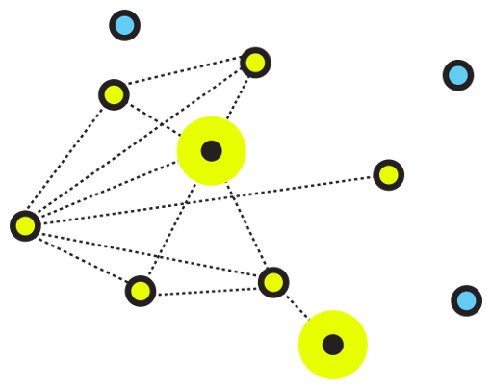

Figure 3.1: An illustrative image for networking

**3.5.2 Computer Network Types**

A computer network is a group of computers linked to each other that enables the computer to communicate with another computer and share their resources, data, and applications. A computer network can be categorized by their size. A **computer network** is mainly of **four types**

1. LAN (Local Area Network)
2. PAN (Personal Area Network)
3. MAN (Metropolitan Area Network)
4. WAN (Wide Area Network)

## LAN (Local Area Network)

1. Local Area Network is a group of computers connected to each other in a small area such as building, office.
2. LAN is used for connecting two or more personal computers through a communication medium such as twisted pair, coaxial cable, etc.
3. It is less costly as it is built with inexpensive hardware such as hubs, network adapters, and Ethernet cables.
4. The data is transferred at an extremely faster rate in Local Area Network.
5. Local Area Network provides higher security.

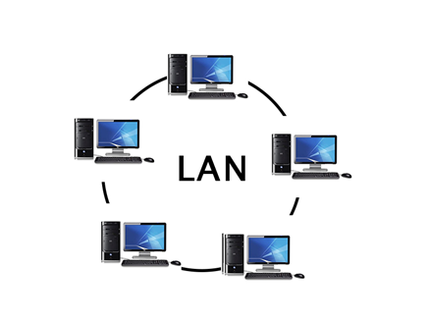

Figure 3.2: Local area network

## PAN (Personal Area Network)

1. Personal Area Network is a network arranged within an individual person, typically within a range of 10 meters.
2. Personal Area Network is used for connecting the computer devices of personal use is known as Personal Area Network.
3. **Thomas Zimmerman** was the first research scientist to bring the idea of the Personal Area Network.
4. Personal Area Network covers an area of **30 feet**.
5. Personal computer devices that are used to develop the personal area network are the laptop, mobile phones, media player and play stations.

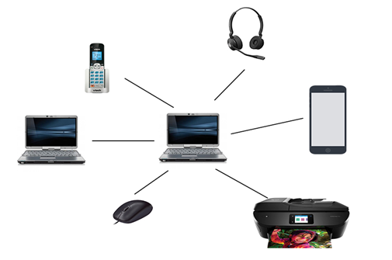

Figure 3.3: Personal area network PAN

**There are two types of Personal Area Network:**

1. Wired Personal Area Network
2. Wireless Personal Area Network

**Wireless Personal Area Network:** Wireless Personal Area Network is developed by simply using wireless technologies such as Wi-Fi, Bluetooth. It is a low range network.

**Wired Personal Area Network:** Wired Personal Area Network is created by using the USB.

### Examples of Personal Area Network:

1. **Body Area Network:** Body Area Network is a network that moves with a person. **For example**, a mobile network moves with a person. Suppose a person establishes a network connection and then creates a connection with another device to share the information.
2. **Offline Network:** An offline network can be created inside the home, so it is also known as a **home network**. A home network is designed to integrate the devices such as printers, computer, television but they are not connected to the internet.
3. **Small Home Office:** It is used to connect a variety of devices to the internet and to a corporate network using a VPN

## MAN (Metropolitan Area Network)

1. A metropolitan area network is a network that covers a larger geographic area by interconnecting a different LAN to form a larger network.
2. Government agencies use MAN to connect to the citizens and private industries.
3. In MAN, various LANs are connected to each other through a telephone exchange line.
4. The most widely used protocols in MAN are RS-232, Frame Relay, ATM, ISDN, OC-3, ADSL, etc.
5. It has a higher range than Local Area Network (LAN

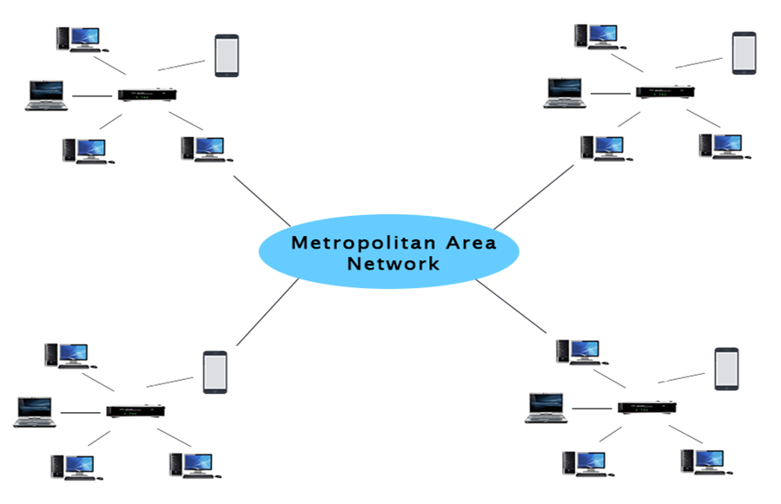

Figure 3.4: Metropolitan area network

### Uses of Metropolitan Area Network:

1. MAN is used in communication between the banks in a city.
2. It can be used in an Airline Reservation.
3. It can be used in a college within a city.
4. It can also be used for communication in the military.

## WAN (Wide Area Network)

1. A Wide Area Network is a network that extends over a large geographical area such as states or countries.
2. A Wide Area Network is quite bigger network than the LAN.
3. A Wide Area Network is not limited to a single location, but it spans over a large geographical area through a telephone line, fiber optic cable or satellite links.
4. The internet is one of the biggest WAN in the world.
5. A Wide Area Network is widely used in the field of Business, government, and education.

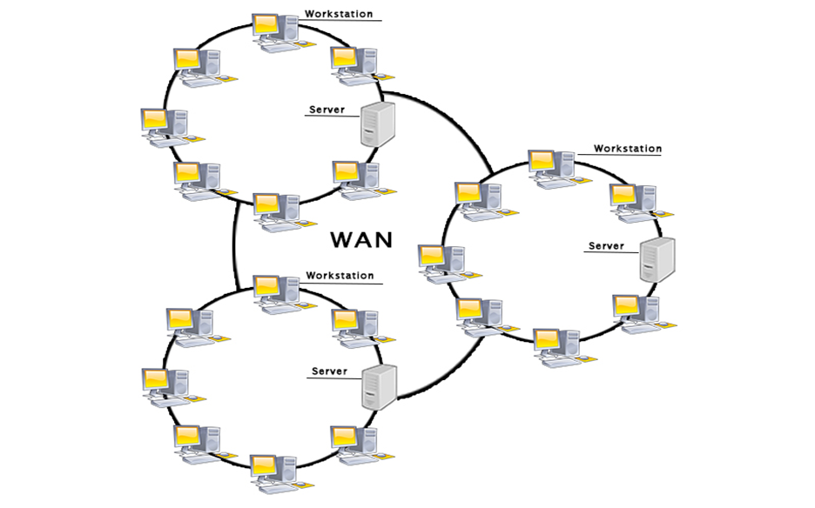

Figure 3.5: Wide area network

**3.5.4 AN ETHERNET CABLE**

Purchasing Ethernet cables can be quite expensive and pre-made lengths are not always the length you need.  Making Ethernet cables is easy with a box of bulk Category 5e Ethernet cable and RJ-45 connectors that are attached to the cut ends of your preferred cable length.

Bulk Ethernet Cable - Category 5e or CAT5e

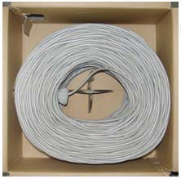

Figure 3.6: Bulk Ethernet Cable - Category 5e or CAT5e

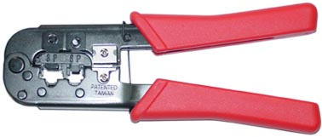

Figure 3.7: RJ-45 Crimping tool

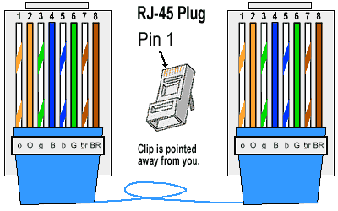

Figure 3.8: RJ45 diagram

**3.5.5 TYPES OF ETHERNET CABLES**

There are two kinds of Ethernet cables you can make, **Straight Through**and **Crossover**.  
**STRAIGHT THROUGH** Ethernet cables are the standard cable used for almost all purposes, and are often called "patch cables". It is highly recommend you duplicate the color order as shown on the left. Note how the green pair is not side-by-side as are all the other pairs. This configuration allows for longer wire runs.

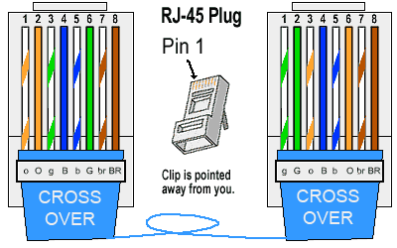

Figure 3.9: Straight through cable

**CROSSOVER CABLES** - The purpose of a Crossover Ethernet cable is to directly connect one computer to another computer (or device) without going through a router, switch or hub.

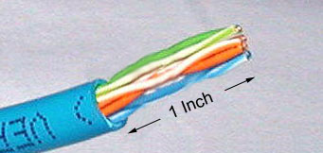

Figure 3.10: Cross over cable

Cut into the plastic sheath about 1inch (2.5 cm) from the end of the cut cable. The crimping tool has a razor blade that will do the trick with practice.

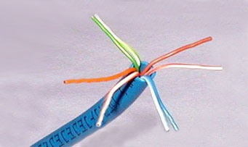

Figure 3.11: Unwind and pair the similar colors.

Pinch the wires between your fingers and straighten them out as shown. The color order is important to get correct.

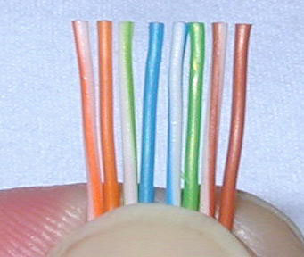

Figure 3.12: Colour order of cables

Use scissors to make a straight cut across the 8 wires to shorten them to 1/2 Inch (1.3 cm) from the cut sleeve to the end of the wires.



Figure 3.12: Scissors

Carefully push all 8 unstripped colored wires into the connector. Note the position of the blue plastic sleeve. Also note how the wires go all the way to the end.

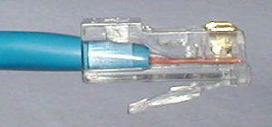

Figure 3.13: Inserting the wires

A view from the top. All the wires are all the way in. There are no short wires.

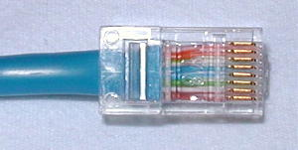

Figure 3.14: Top view of the inserted wires

**WRONG WAY** - Note how the blue plastic sleeve is not inside the connector where it can be locked into place. The wires are too long. The wires should extend only 1/2 inch from the blue cut sleeve. Note how the wires do not go all the way to the end of the connector.

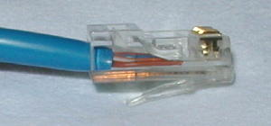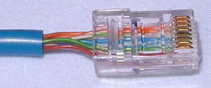

Figure 3.15: Wrong way of inserting the wires

**CRIMPING THE CABLE** ... carefully place the connector into the Ethernet Crimper and cinch down on the handles tightly. The copper splicing tabs on the connector will pierce into each of the eight wires. There is also a locking tab that holds the blue plastic sleeve in place for a tight compression fit. When you remove the cable from the crimper, that end is ready to use.

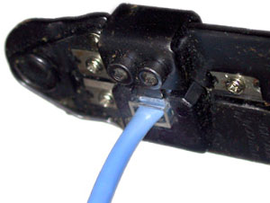

Figure 3.16: Crimping the cable

For a standard "Straight Through" cable, repeat all steps and wire color order on the other end of cable. For a cross-over cable, the other end will have a different color order as shown by the crossover picture above. Make sure to test the cables before installing them. An inexpensive Ethernet cable tester does this quite well.

**CHAPTER FOUR**

**SUMMARY, CONCLUSION, PROBLEMS AND RECOMMENDATIONS**

# 4.1 SUMMARY

The relevance of the SIWES program cannot be over emphasized considering the fact that it has significantly reduced the gap between my theoretical and practical knowledge about computer hardware and software, installations, maintenance and networking. The processes of communication which include data and telecommunication the use of switch in the networking and what networking is all about.

The program is indeed a commendable one in that it affords students ample opportunities of being exposed to good working relationship with colleagues and the field experience with customers. This little exposure has widened my knowledge about my course of study, not only that it has automatically changed my views about lift in general. The firm at large has taught me how to be independent of my own how to be conscious of my health and safety at its peak relating to the environment where I carried out my SIWES program. It was indeed a highly rewarding experience to be with Polis Computers, Michika, Adamawa State.

**4.2 CONCLUSION**

In conclusion, I thank ITF in general for their effort towards the Student Industrial Training Scheme. The contribution that the industrial training offered to student will not be over emphasized. It has exposed me seriously to a certain depth and length of practical capability on Computer Knowledge and practical Know how.

It has also acquainted me with the working condition, which I am expected to encounter in the near future. I will say that SIWES has a greater advantage on me, it has greatly exposed me to the practical application of all that I have been through in the school, SIWES is an experience that all student must pass through this is because it gives a full practical knowledge of what has been through in classroom.

Finally, I have a strong believe that this comprehensive based on the experience, I acquired during the industrial training scheme will convince every user training is not difficult.

I therefore strong conclude that the continuous existence of SIWES programme as it is very necessary since it plays a dominant role in the development of student of Computer Science in the acquisition of practical experience.

# 4.3 PROBLEMS OBSERVED DURING MY PROGRAM

1. The time frame set for the program is too short as some of the aspects of the program where not completed.
2. Lack of Financial support from the company to aid transportation to and from training.
3. Attentions are not given to the IT students by the workers it is learn if you want to learn or ask if you want to know.
4. Cost of Training: The Student has to be registered as a student of a particular organization in order to carry out the program.

**4.4 RECOMMENDATIONS**

Below are the recommendations that should be given serious consideration so as alleviate the suffering of students undergoing SIWES.

Firstly, the Federal Government of Nigerian should make a positive effort in reducing the overall cost of production so that companies should be producing to fill capacity and accommodate SIWES populaces. Also, certain monthly allowance may be given to the student by company accepted then (student to ease transportation problem).

Secondly, the Industrial Training Fund (ITF), should try and increase the money paid at the end of SIWES to the student so as to justify the Cost of Living we experienced.

Finally, the ITF official should please continue visiting the students, to ensure that what they are learning is in line with the ITF requirement.

**REFERENCES**

Edward, B. M.D (2003). The Effect of SIWES on a student, Federal Ministry of Works, Lagos. Nigeria.

Lowenthal, R. (2009).[*Improving the Design of PowerPoint Presentations*](http://www.ucdenver.edu/academics/CUOnline/FacultySupport/Handbook/Documents/Chapter_12.pdf). University of Colorado Denver.